BEING LGBTI IN THE CARIBBEAN (BLIC)
Bi-Annual Report
- -10-2023 to 31-03-2024

Submission Date: June 03, 2024

[Contract/Agreement] Number: AID-517-IO-17-00001
Activity Start Date and End Date: September 22, 2018, to February 28, 2025
[COR/AOR] Name: Luis Duran

Submitted by Jean Sano Santana, Chief of Party
United Nations Development Programme
City of Knowledge, Building 128, Panama City, Panama
Tel: +507 302 4610
Email: jean.sano.santana@undp.org

This document was produced for review by the United States Agency for International Development in the Dominican Republic (USAID/DR).

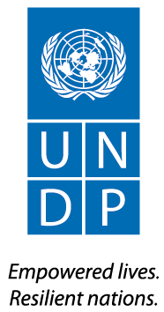

Program Overview/Summary
Program Name: | Being LGBTI in the Caribbean (BLIC)
Activity Start Date and End Date: | September 22, 2017, to February 28, 2025
Name of Prime Implementing Partner: | United Nations Development Programme
[Contract/Agreement] Number: | AID-517-IO-17-00001
Name of Subcontractors/Sub-awardees: | Barbados and Eastern Caribbean  Equals Barbados  Cari-Flags  Dominican Republic:  ProActividad  Jamaica  TransWave  Open for Business-Caribbean  Guyana  Guyana Trans United  Regional:  Eastern Caribbean Alliance for Diversity and Equality - ECADE
Major Counterpart Organizations: | Not Applicable
Geographic Coverage  (cities and or countries): | Barbados, Dominican Republic, Guyana, and Jamaica
Reporting Period: | October 1, 2023, to March 31, 2024

Contents
1. Program Overview/Summary 0
1.1 Program Description/Introduction 2
2. ACTIVITY IMPLEMENTATION PROGRESS 2
2.1 Progress Narrative 2
2.2 Implementation Status 3
2.3 Implementation Challenges 7
2.4 Gender Equality and Female Empowerment 7
2.5 Science, Technology, and Innovation (STIP) Impacts 7
2.6 Public Private Partnerships (PPP) and Global Development Alliance (GDA) Impacts 8
2.7 LGBTI Inclusion 8
LGBTI inclusion is the focus of the project. 8
2.8 Inclusion of Persons with Disabilities (PwD) 8
3. Environmental Compliance 9
4. STAKEHOLDER PARTICIPATION AND INVOLVEMENT 9
5. MANAGEMENT AND ADMINISTRATIVE ISSUES 9
6. Budget 9
7. LESSONS LEARNED 9
8. PLANNED ACTIVITIES FOR NEXT QUARTER INCLUDING UPCOMING EVENTS 10
9. How IMPLEMENTING PARTNER has addressed A/COR comments from the last quarterly OR Semi-annual report 11

Program Description/Introduction
Being LGBTI in the Caribbean (BLIC) is a regional programme that aims to enhance knowledge, partnerships, and capacities of LGBTI communities, civil society, and States to reduce human rights violations and negative attitudes towards LGBTI people in the Caribbean, with country level focus in Barbados, Dominican Republic, Guyana, and Jamaica, as well as regional activities. To achieve its goals, it is crucial that the project responds to the experiences and needs of the LGBTI community in the Caribbean.

Research and data collected by the project have highlighted that the transgender community, especially transgender women, as the most marginalized segment of the LGBTI groups. As a result, building on the work and milestones achieved under first and second phases of the project (2017-2023), the ongoing third phase focuses on the socio-economic empowerment of transgender women and gender diverse persons through inclusive public policies and model interventions. The objectives of the project are as follows:

- To support the governments of Barbados, Dominican Republic, Guyana, and Jamaica in the revision of policies for the social, economic, and labor inclusion of transgender and gender diverse persons.
- To strengthen the capacities of civil society groups and community organizations of transgender persons to advocate for the revision of policies for the economic and labor inclusion of transgender and gender diverse persons.
- To promote the individual economic and labor inclusion of transgender women in Barbados, Dominican Republic, Guyana, and Jamaica.
This new phase of the project will be implemented in collaboration with governments, civil society, regional institutions, and other stakeholders to advance the social-economic inclusion of transgender women.

This report covers the six months of project implementation (October 2022 to March 2023) providing an overview of conducted activities and upcoming initiatives.

ACTIVITY IMPLEMENTATION PROGRESS

Progress Narrative
During this reporting period, the project has focused on establishing national-level support systems to provide direct services to transgender women and gender diverse individuals. This groundwork has involved engaging key stakeholders and ensuring national buy-in.
In this context, LGBTI civil society organizations responsible for delivering direct services to the project's program participants have been selected in all implementing countries. Their responsibilities include selecting project participants, developing referral systems, and building capacity within government agencies, academic institutions/training providers and other relevant stakeholders.
The project has supported a total of six (6) LGBTI+ civil society organizations in Barbados (1); Dominican Republic (1); Jamaica (2) and at the regional level (2).
For example, in Jamaica UNDP partnered with Open for Business Caribbean. Under the theme, “A path towards inclusion and diversity in Jamaica’s Tourism Industry” this workshop aimed to raise awareness about the importance of LGBTQ travelers to the Caribbean tourism market, as well as to identify barriers and opportunities to promote LGBTQ inclusive corporate policies in the tourism industry. Through this engagement, the capacity of civil society organizations, public sector and LGBT entrepreneurs was strengthened by discussing strategies for promoting LGBTQ inclusion within the tourism sector; both recreational and within the labor force. These discussions had a particular focus on further marginalized groups including that of gender diverse persons and the transgender community. The workshop resulted in the development of recommendations to create a more inclusive workforce. As a result of this activity, a total of 15 participants received training, increasing their knowledge of the development of an inclusive tourism industry.

From a regional perspective, CariFLAGS was supported to convene LGBTI organization from across the Caribbean in a Regional Conference under the theme “Stronger Together - Defining our Regional Identity and Strategic Priorities”. The Conference was organized in partnership with International Lesbian, Gay, Bisexual, Trans and Intersex Association North America and the Caribbean (ILGA NAC). This first of its kind, the conference brought together activists and stakeholders from the English and Dutch-speaking Caribbean (the Haitian participants were unfortunately unable to attend due to the country’s security situation), the United States and Canada.
Additionally, UNDP convened various stakeholder engagement meetings with the private sector, civil society organizations and educational institutions with the aim to familiarize them of the programme and to establish strategic partnerships to bolster project implementation at country level.

Implementation Status
Output 1: Knowledge, strategic information, and evidence on the impact of inequality and exclusion of LGBTI people developed and disseminated.
Indicator: Number of research papers on LGBTI produced.
An Inception Report on “Inclusive Social Protection and Poverty Alleviation Programs in Barbados, Guyana, and Jamaica” has been drafted in which social protection as a concept is defined, an overview of the socio-economic and political environments in the three countries is given along with a preliminary analysis of the poverty, social exclusion and marginalization faced by transgender women and gender diverse persons. On the ground activities for qualitative data collection are well underway.
Similarly, UNDP is developing the Diagnostic Report on Access Barriers to Social Protection and the Labor Market for Transgender and Gender Diverse People in the Dominican Republic. This research aims to understand and document the specific obstacles that transgender women and gender diverse individuals encounter in accessing the labor market and social protection. These barriers include workplace discrimination and harassment, precarious employment conditions, and limited access to social security. The research was conducted qualitatively, focusing on interviews with key stakeholders, analysis of public policies, previous studies, and comprehensive reviews of laws and policies related to the human rights of LGBTI people. This approach provides a thorough understanding of the lived experiences and perceptions of trans and gender diverse individuals in the Dominican Republic. The preliminary draft of this report has been submitted to UNDP by the consultant, following interpretation workshops with key informants.
Output 2: Policies and tools that enable conditions for equitable access to decent jobs for transgender women and gender diverse persons.
Indicator: Number of vulnerable persons benefitting from USG-supported social services
As mentioned in previous sections, the project has selected implementing partners for all project countries: Equals in Barbados, ProActividad in the Dominican Republic, Guyana Trans United in Guyana, and TransWave in Jamaica. All selected partners have received technical support in drafting the Responsible Party Agreement, identifying the necessary resources for effective activity implementation, and convening stakeholder meetings with public and private sector entities, as well as educational and vocational institutions.
Additionally, the project has conducted thorough selection processes for social workers and psychologists who will provide direct assistance to transgender women and gender diverse individuals at the country level. While this process has taken time, it is essential to ensure that the quality and safety of the services provided through the project meet UNDP's standards.

Output 3: Capacity of transgender community groups developed through enhanced coordination, increased access to existing tools, transfer of knowledge and concrete actions to address stigma and discrimination.
Indicator: Number of persons trained to advance outcomes consistent with gender equality or female empowerment through their roles in public or private sector institutions or organizations
In Jamaica, the capacity of fifteen (15) participants from civil society organizations, public sector and entrepreneurs was strengthened in establishing more inclusive spaces within the tourism sector may it be through employment or recreational activities. The workshop highlighted the value chain of LGBTQ travelers to the Caribbean tourism market, identified barriers and opportunities for inclusion and resulted in the development of recommendations in creating a more inclusive workforce for the community. This workshop had a particular focus on transgender women and was organized in partnership with Open for Business.
Indicator: Number of human rights organizations trained and supported
A total of six organizations have been supported by the project for the current reporting period: Equals, Pro Actividad, TransWave, Open for Business, ECADE and CariFLAGS. Of these, 100% are LGBTI organizations and four (4) also work on issues related to the human rights of women.
For example, in Barbados, technical and other support was provided to Equals throughout March 2024 including assistance with the formulation of petty cash procedures, approval to reallocate funds to purchase a safe and lockable filing cabinet to secure cash and sensitive records of project participants, assistance with drafting of Terms of Reference for the Project Manager and Project Assistant, assistance with development of the sign-up form for the inclusion programme, along with a participant recruitment strategy.
In the case of the Dominican Republic, the project held a High-Level Meeting for the Launch of the Third Phase of the project on Wednesday, October 31, 2023. This high-level meeting included various representatives from Dominican state institutions, international cooperation, and civil society. The objective was to inform about the intervention strategy of this phase of the project and to discuss potential inter-institutional cooperation lines. Present at the event were Nairobi Castillo, Executive Director of COTRAVETD; Dilia Leticia Jorge Mera, Deputy Minister of Innovation, Transparency, and Citizen Services; Rebecca Latorraca, Director of USAID; and Inka Mattila, UNDP Resident Representative.

Implementation Challenges
The modality under which UNDP is engaging CSO partners, called a Responsible Party Agreement includes regulations and safeguards that some transgender organisation found exacting. Consequently, the project team met with potential implementing partners to explain the process, discuss proposal templates, and address other technical aspects, such as the preparation of detailed project proposals and budgets. This, for example, implied that the selection process in the Dominican Republic and Guyana had to be extended, to ensure that participation from LGBTI organizations in the process.
Additionally, in accordance with internal regulations and standards, potential implementing partners in each country had to undergo an assessment before the respective Responsible Party Agreement could be signed. This extensive process required substantial dedication from the implementing partners, and technical support from the National Project Coordinators, and the wider project team to finalize the direct contracting and commence project implementation.

Gender Equality and Female Empowerment
The project addresses gender equality in the broader sense, challenging the culturally-defined set of economic, social, and political roles, responsibilities, rights, entitlements obligations, associated with being female and male, and the sigma and discrimination that is directed at an individual based on biological sex, intersex status, gender identity (e.g., transgender), or behaviours that are not in line with social expectations of what it means to be a man or woman, boy or girl (e.g., gay men).

Science, Technology, and Innovation (STIP) Impacts
The project´s social media accounts, blog and the UNDP website are important outlet to communicate project activities and results. This includes:

● X: https://twitter.com/LGBTICaribbean
  - 1,340 followers (30 more than the previous six-month period).
  - 2099 impressions (number of times users saw our tweets).
● Instagram: https://www.instagram.com/lgbticaribbean/
  - 8 posts in the last 6 months and 1,730 followers (36 new followers in this period)
  - 5,557 accounts reached
  - 23,72% of our followers are from 4 beneficiary countries of the project, these being Dominican Republic (21,05), Jamaica (7.4%), Barbados (4.5%). 48% of our followers are among 25-34 years old; the next age ranges being 35-44 (24.1%) and 18-24 (16.5%)
● Facebook: https://www.facebook.com/LGBTICaribbean
  - 1346 followers (36 more than in previous 6-month period)
  - 5 posts reaching 343 people, 29 engagements (reactions, likes, comments or shares.
  - BLIC’s Facebook page followers are distributed as follows: Haiti (21.05%), Dominican Republic (13.16%), USA (11.14%), Venezuela (7.54%), Guyana (7.11%), Jamaica (3.43), Canada (2.89) and others (33.66%) in that order. These include Russia, South Africa, Turkey, Cuba, Senegal, Bolivia, and many others with approximately 0.35% each. Targeted posts and advertisements are recommended to reach our main beneficiary countries.
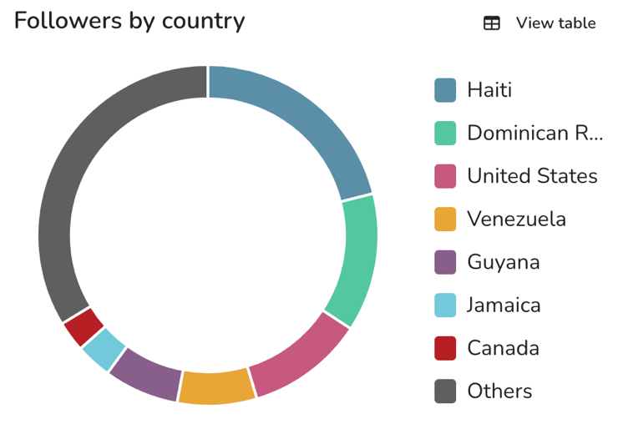

Public Private Partnerships (PPP) and Global Development Alliance (GDA) Impacts
In Barbados, the project started conversations with Scotiabank aiming to explore regional-level efforts to promote corporate inclusive policies.

2.7 LGBTI Inclusion

LGBTI inclusion is the focus of the project.

2.8 Inclusion of Persons with Disabilities (PwD)
Where possible the project includes sign language interpretation or subtitles.

Environmental Compliance
The Project is in compliance with USAID Environmental regulations.

STAKEHOLDER PARTICIPATION AND INVOLVEMENT
In all project countries, inception meetings were held with key stakeholders to announce the launch of the third phase of the project.
For example, in Barbados, civil society and private sector stakeholders were informed about BLIC Phase III, and preliminary discussions on potential collaboration areas were held. Many stakeholders were engaged through introductions made at the CariFLAGS regional conference, including ILGA, Commonwealth Parliamentary Association, Outright International, Human Dignity Trust, CAISO: Sex and Gender Justice, and Renacer (a new Barbadian human rights organization). Other stakeholders engaged included Parliamentarians for Global Action (PGA), Pink Coconuts, Open for Business, the LGBTQ+ Coalition of Barbados, Scotiabank Barbados, and Community Education Empowerment & Development (CEED).
In the Dominican Republic, the project has served as a catalyst for engaging a broader range of national stakeholders on issues related to the human rights of LGBTI individuals. For instance, during their participation in the high-level meeting to launch the project, the Ministry of Labour committed to involving their Department of Inclusion in project activities. Similarly, the Unified System of National Beneficiaries (SIUBEN) will conduct a registration drive for transgender women participants of the project to promote their enrolment in the Unified Social Protection Beneficiary System. This initiative aims to effectively identify and target strategies for transgender individuals, linking them to the national social protection system.
In Jamaica, the project engaged in conversations that will lead to an agreement between the implementing CSO and Heart Trust Jamaica, a national-wide vocational institute that aims to build and sustain a globally competitive Jamaican labour force.

MANAGEMENT AND ADMINISTRATIVE ISSUES

Given the immense pressure the procurement teams in project countries are facing, internal procedure timing has delayed project actions. During the reporting period, the BLIC Team has relied on the Regional Hub team for procurement and payments. Moving forward, procurement procedures will be decided on a case-by-case basis as well as how funds will be disbursed to suppliers. In some instances, country offices would be used to contract and disburse funds to local suppliers as local transactions are processed by the local banking system much faster than overseas transactions. However, if the country offices procurement and financial teams are under pressure, the Regional Hub will be used instead.

Budget
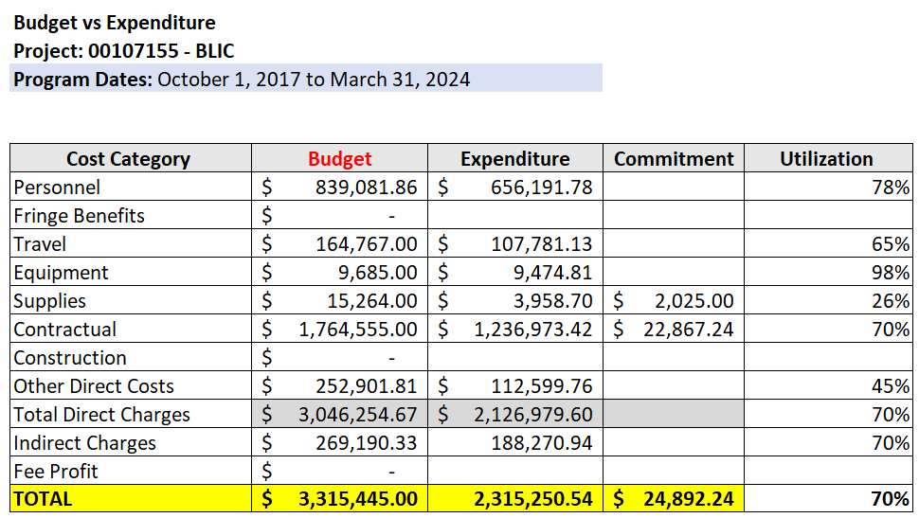

LESSONS LEARNED
The sharing of documentation to include Responsible Party Agreements and Terms of References for various consultancies across participating territories served to be useful and time savings measure. In fostering such collaboration, the team experienced some levels of acceleration of activity implementation and with the standardization of documentation, this increases the probability of maintaining high levels of quality of project outputs.
The project has identified that many LGBTI organizations in the project countries have challenges in proposal construction and development. Therefore, it is essential to focus on this area during training sessions and emphasize mentoring in the upcoming period.

PLANNED ACTIVITIES FOR NEXT QUARTER INCLUDING UPCOMING EVENTS
BARBADOS
- National Project Coordinator’s participation in a breakfast roundtable discussion with the UK Special Envoy on LGBTQ+ Rights Lord Nick Herbert and Barbadian LGBTQ+ activists
- Further dissemination of survey of transgender and gender-diverse aimed at collecting data on their experiences accessing social assistance in Barbados
- Focus Group with transgender and gender diverse people to collect further qualitative data
- Finalization of the recruitment of the Project Assistant by Equals
- Finalization of the recruitment of the Social Worker and Psychologist consultants.
- Supporting a local CSO with their 2024 IDAHOBIT event in May 2024
- Supporting Pride activities in June 2024
- Continuing stakeholder engagement – focusing more on the government and private sector in the upcoming quarter.
- Supporting Equals in the enrollment and delivery of services to program participants.
- Conduct monitoring visit.

GUYANA
- Onboarding of the BLIC III National Coordinator.
- Recruitment of social workers and psychologist consultants.
- Facilitation of focus group discussions with key stakeholders to allow for data collection of the Inclusive Social Protection and Poverty Alleviation Programs in Barbados, Guyana, and Jamaica study being conducted.
- Complete de Responsible Party Agreement with Guyana Trans United.
- Support local CSOs on activities under LGBT Pride Month 2024.
- Conduct monitoring visit.

DOMINICAN REPUBLIC
- Conducting an enrolment drive within the SIUBEN system.
- Conduct a retreat of the PROACTIVIDAD programmatic team to facilitate training for project promoters and foster collaboration with psychology and social work professionals.
- training on SIUBEN registration and enrolment processes so that Partner NGOs can assist transgender women entering the program.
- Supporting PROACTIVIDAD in the enrollment and delivery of services to program participants
- Finalizing and publishing the “Diagnosis of Access to the Labor Market and Social Protection for Transgender People in the Dominican Republic.”
- Support local activities in the context of International Day Against Homophobia and Transphobia (IDAHOT) and celebrating the World Day of the Spirit.
- Support local CSOs on activities under LGBT Pride Month 2024.
- Finalization of the recruitment of the Social Worker and Psychologist consultants.

JAMAICA
- Onboarding of the BLIC III Project Associate.
- Signing of Strategic Partnership Agreement with the HEART/NSTA Trust.
- Recruitment of social workers and psychologist consultants.
- Support to Equality for All Foundation Limited for proposed IDAHOBIT 2024 activities.
- Facilitation of focus group discussions with key stakeholders to allow for data collection of the Inclusive Social Protection and Poverty Alleviation Programs in Barbados, Guyana, and Jamaica study being conducted.
- Complete de Responsible Party Agreement with TransWave Jamaica.

COMMUNICATIONS:
- Develop and design content for IDAHOBIT.
- Develop and design content for PRIDE.
- Ongoing social media present posting.

How IMPLEMENTING PARTNER has addressed A/COR comments from the last quarterly OR Semi-annual report
Not Applicable

Accounts engaged: number of accounts that have interacted with the content.

